Display Standards Policy and Process
OPERATIONAL DEFINITION: A reference point for teachers and students to assist them with lesson tasks or automatizing information.
INTENT:
- To provide students with an interactive resource that can be used as a guide to support learning.
- For teachers to use as a reference point for students still automatizing information.
MINIMUM EXPECTATIONS:
Display must be:
- Interactive
- Description of terms/definition (with examples)
- Process
- Demonstration of students achievement
Have the following list of changeable display items at all times:
- This week’s explicitly taught content.
- The previous weeks explicitly taught content.
- Writing warm up elements.
- Numeracy warm up elements.
- Spelling weekly words.
- Blending warm up.
- Segmenting warm up.
- Vocabulary.
- One literacy you do/portfolio task.
- One numeracy you do/portfolio task.
- Latest reward/excursion/accomplishment (photos).
- Student goals.
Have the following list of permanent display items at all time:
- Fleming 3 imperatives, 6 givens, 4 pillars.
- School rules and values.
- Issues flowchart.
- Behaviour management chart.
- Emergency/Allergies Information.
Display items should:
- Be readable by all students from their desk or the floor.
- Have an explanation of the lesson outcome and you do task (if you do/portfolio task)
- Have a title to notify teachers and students of display (e.g. Numeracy Warm Ups).
- Be marked with adequate feedback (if a you do/portfolio task).
- Follow the FSPS bookwork presentation standards.
- Be neatly presented either with a boarder, coloured backing or laminated.
EXAMPLES:
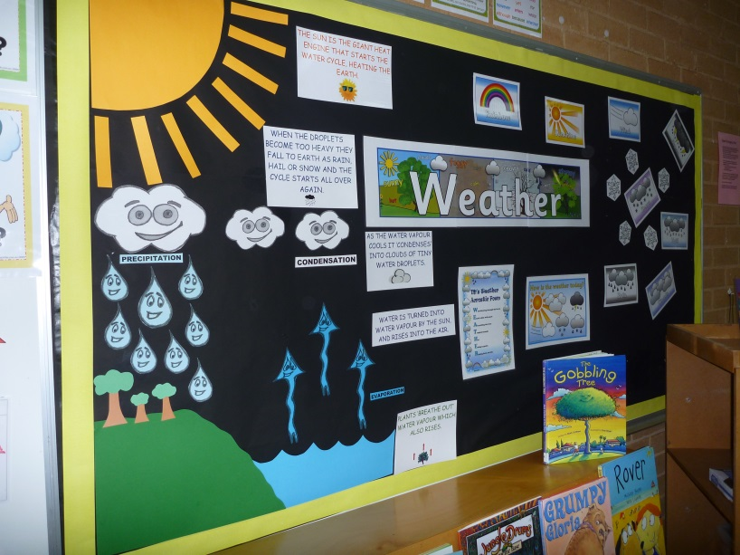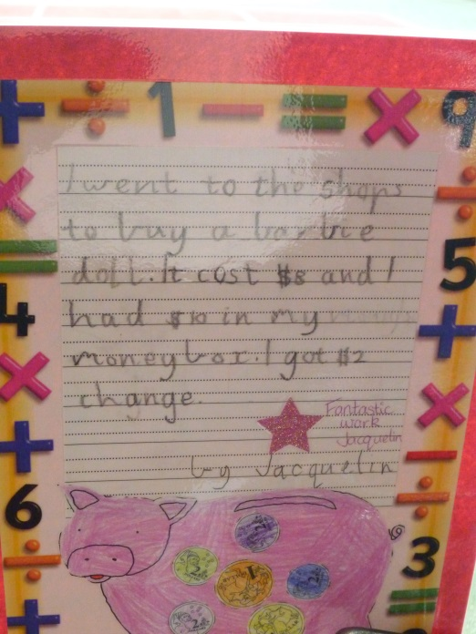
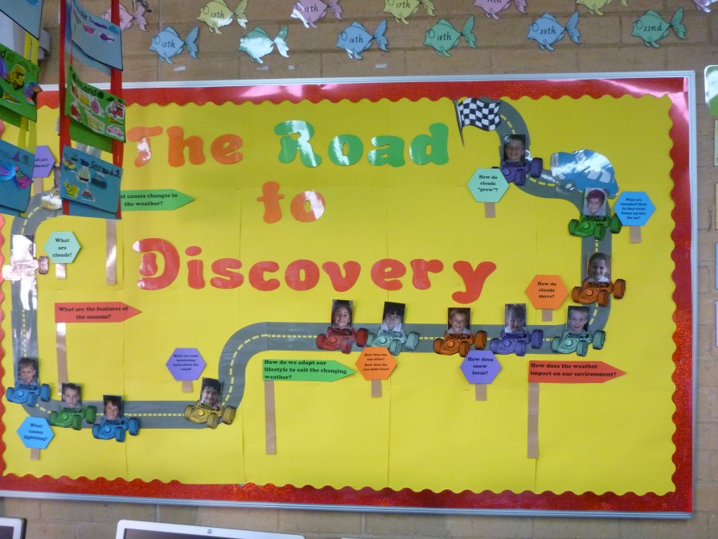
DISCLAIMER:
Please sign below to signal your understanding and compliance with Fisk Street Primary School’s position on Display Standards.
DISPLAY EXPECTATIONS
TEACHER INFORMATION CHECKLIST
ROOM NUMBER: ____ DATE: __/__/__
Criteria/Description
Types of Display
At least one interactive display –

At least one description display –

At least one process display –

At least two demonstration of achievement displays –

Changeable Display Items
This week’s explicitly taught content –

Last week’s explicitly taught content –

Writing warm up –

Numeracy warm up –

Spelling weekly words –

Blending warm up –

Segmenting warm up –

Vocabulary –

At least one literacy you do/portfolio task –

At least on numeracy you do/portfolio task –

Display of either latest reward/excursion/accomplishment –

Notes: ___________________________________________________________________________________________________________________________________________________________________________________________________________________________________________________________________________________________________________________________________________________________________________________________________________________________________________________________________________________________
DISPLAY CHECKLIST
Criteria/Description | Rating | Presentation
Types of Display
At least one interactive display – | Yes/No | 1 | 2 | 3
At least one description display – | Yes/No | 1 | 2 | 3
At least one process display – | Yes/No | 1 | 2 | 3
At least two demonstration of achievement displays – | Yes/No | 1 | 2 | 3
Changeable Display Items
This week’s explicitly taught content – | Yes/No | 1 | 2 | 3
Last week’s explicitly taught content – | Yes/No | 1 | 2 | 3
Writing warm up – | Yes/No | 1 | 2 | 3
Numeracy warm up – | Yes/No | 1 | 2 | 3
Spelling weekly words – | Yes/No | 1 | 2 | 3
Blending warm up – | Yes/No | 1 | 2 | 3
Segmenting warm up – | Yes/No | 1 | 2 | 3
Vocabulary – | Yes/No | 1 | 2 | 3
At least one literacy you do/portfolio task – | Yes/No | 1 | 2 | 3
At least on numeracy you do/portfolio task – | Yes/No | 1 | 2 | 3
Display of either latest reward/excursion/accomplishment – | Yes/No | 1 | 2 | 3
Permanent Display Items
Fleming 3 imperatives, 6 givens, 4 pillars – | Yes/No | 1 | 2 | 3
School rules and values – | Yes/No | 1 | 2 | 3
Issues Flowchart – | Yes/No | 1 | 2 | 3
Behaviour management flowchart – | Yes/No | 1 | 2 | 3
Emergency/allergies information – | Yes/No | 1 | 2 | 3

